Лабораторна робота № 5
АУТЕНТИФІКАЦІЯ ТА АВТОРИЗАЦІЯ. РОБОТА З WEB API. JSON WEB TOKEN.
Мета: набути навичок роботи з механізмами аутентифікації та авторизації користувачів в ASP.NET, набути навичок роботи з Web API.
Хід роботи:
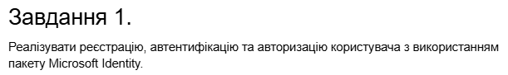
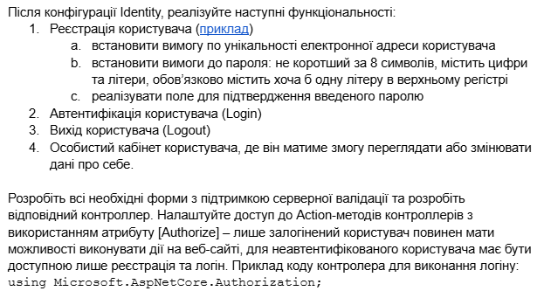

Лістинг коду(Створення Реєстрації та Автентифікації користувачів):
using Microsoft.AspNetCore.Identity;
using Microsoft.AspNetCore.Mvc;
using Microsoft.IdentityModel.Tokens;
using System.IdentityModel.Tokens.Jwt;
using System.Security.Claims;
using System.Text;

namespace CinemaBooking.Api.Controllers
{
[Route("api/[controller]")]

[ApiController]
public class AccountController : ControllerBase
{
private UserManager<IdentityUser> userManager;
private RoleManager<IdentityRole> roleManager;
private IConfiguration configuration;

public AccountController(UserManager<IdentityUser> userMgr,
RoleManager<IdentityRole> roleMgr,
IConfiguration config)
{
userManager = userMgr;
roleManager = roleMgr;
configuration = config;
}

[HttpPost("register")]
public async Task<IActionResult> Register([FromBody] RegisterRequest model)
{
var user = new IdentityUser
{
UserName = model.UserName,
Email = model.Email
};

var result = await userManager.CreateAsync(user, model.Password);
if (result.Succeeded)
{
string role = model.Role ?? "User";
if (await roleManager.RoleExistsAsync(role))
{
await userManager.AddToRoleAsync(user, role);
}
return Ok(new { Message = "Користувача зареєстровано успішно" });
}

return BadRequest(result.Errors);
}

[HttpPost("login")]
public async Task<IActionResult> Login([FromBody] LoginRequest model)
{
var user = await userManager.FindByNameAsync(model.UserName);
if (user != null && await userManager.CheckPasswordAsync(user, model.Password))
{
var roles = await userManager.GetRolesAsync(user);

var claims = new List<Claim>
{
new Claim(ClaimTypes.Name, user.UserName!),
new Claim(ClaimTypes.NameIdentifier, user.Id),
new Claim(JwtRegisteredClaimNames.Jti, Guid.NewGuid().ToString())
};

foreach (var role in roles)
{
claims.Add(new Claim(ClaimTypes.Role, role));
}

var key = new SymmetricSecurityKey(
Encoding.UTF8.GetBytes(configuration["Jwt:Key"]!));
var creds = new SigningCredentials(key, SecurityAlgorithms.HmacSha256);

var token = new JwtSecurityToken(
issuer: configuration["Jwt:Issuer"],
audience: configuration["Jwt:Audience"],
claims: claims,
expires: DateTime.Now.AddHours(3),
signingCredentials: creds
);

return Ok(new
{
Token = new JwtSecurityTokenHandler().WriteToken(token),
Expiration = token.ValidTo
});
}

return Unauthorized(new { Message = "Невірне ім'я або пароль" });
}
}

public class RegisterRequest
{
public string UserName { get; set; } = string.Empty;
public string Email { get; set; } = string.Empty;
public string Password { get; set; } = string.Empty;
public string? Role { get; set; }
}

public class LoginRequest
{
public string UserName { get; set; } = string.Empty;
public string Password { get; set; } = string.Empty;
}
}

Лістинг коду(Program.cs):
using Microsoft.EntityFrameworkCore;
using Microsoft.AspNetCore.Identity;
using Microsoft.AspNetCore.Authentication.JwtBearer;
using Microsoft.IdentityModel.Tokens;
using System.Text;
using CinemaBooking.Data;

var builder = WebApplication.CreateBuilder(args);

builder.Services.AddControllers()
.AddJsonOptions(opts => {
opts.JsonSerializerOptions.ReferenceHandler =
System.Text.Json.Serialization.ReferenceHandler.IgnoreCycles;
});

builder.Services.AddEndpointsApiExplorer();
builder.Services.AddSwaggerGen();

builder.Services.AddDbContext<CinemaDbContext>(opts => {
opts.UseSqlite(builder.Configuration["ConnectionStrings:CinemaConnection"]);
});

builder.Services.AddDbContext<AppIdentityDbContext>(opts => {
opts.UseSqlite(builder.Configuration["ConnectionStrings:IdentityConnection"]);
});

builder.Services.AddIdentity<IdentityUser, IdentityRole>(opts => {
opts.Password.RequiredLength = 8;
opts.Password.RequireDigit = true;
opts.Password.RequireLowercase = true;
opts.Password.RequireUppercase = true;
opts.Password.RequireNonAlphanumeric = false;
opts.User.RequireUniqueEmail = true;
}).AddEntityFrameworkStores<AppIdentityDbContext>();

builder.Services.AddAuthentication(opts => {
opts.DefaultAuthenticateScheme = JwtBearerDefaults.AuthenticationScheme;
opts.DefaultChallengeScheme = JwtBearerDefaults.AuthenticationScheme;
})
.AddJwtBearer(opts => {
opts.TokenValidationParameters = new TokenValidationParameters
{
ValidateIssuer = true,
ValidateAudience = true,
ValidateLifetime = true,
ValidateIssuerSigningKey = true,
ValidIssuer = builder.Configuration["Jwt:Issuer"],
ValidAudience = builder.Configuration["Jwt:Audience"],
IssuerSigningKey = new SymmetricSecurityKey(
Encoding.UTF8.GetBytes(builder.Configuration["Jwt:Key"]!))
};
});

builder.Services.AddScoped<ICinemaRepository, EFCinemaRepository>();
var app = builder.Build();
if (app.Environment.IsDevelopment())
{
app.UseSwagger();
app.UseSwaggerUI();
}
app.UseAuthentication();
app.UseAuthorization();
app.MapControllers();
SeedData.EnsurePopulated(app);
IdentitySeedData.EnsurePopulated(app).Wait();

app.Run();

Лістинг коду(Ініціалізація адміна):
using Microsoft.AspNetCore.Builder;
using Microsoft.AspNetCore.Identity;
using Microsoft.EntityFrameworkCore;
using Microsoft.Extensions.DependencyInjection;

namespace CinemaBooking.Data
{
public static class IdentitySeedData
{
public static async Task EnsurePopulated(IApplicationBuilder app)
{
using var scope = app.ApplicationServices.CreateScope();

var context = scope.ServiceProvider.GetRequiredService<AppIdentityDbContext>();
if (context.Database.GetPendingMigrations().Any())
{
context.Database.Migrate();
}

var roleManager = scope.ServiceProvider.GetRequiredService<RoleManager<IdentityRole>>();
var userManager = scope.ServiceProvider.GetRequiredService<UserManager<IdentityUser>>();

string[] roles = { "Admin", "User" };
foreach (var role in roles)
{
if (!await roleManager.RoleExistsAsync(role))
{
await roleManager.CreateAsync(new IdentityRole(role));
}
}

string adminEmail = "admin@cinema.com";
string adminPassword = "Admin1234";

if (await userManager.FindByEmailAsync(adminEmail) == null)
{
var admin = new IdentityUser
{
UserName = "admin",
Email = adminEmail
};
var result = await userManager.CreateAsync(admin, adminPassword);
if (result.Succeeded)
{
await userManager.AddToRoleAsync(admin, "Admin");
}
}
}
}
}

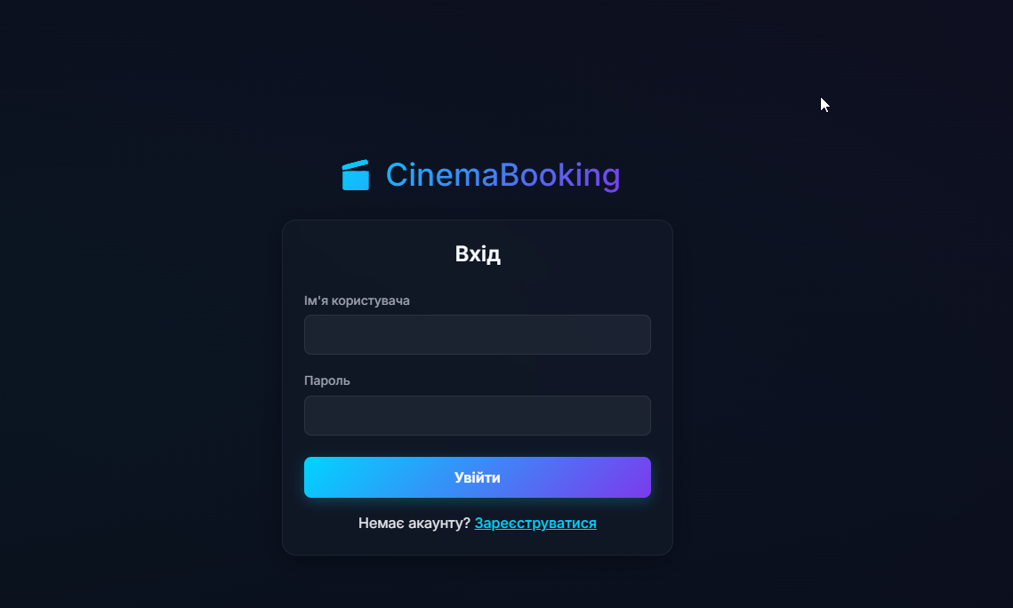
Рис. 1. Логін та реєстрація користувача

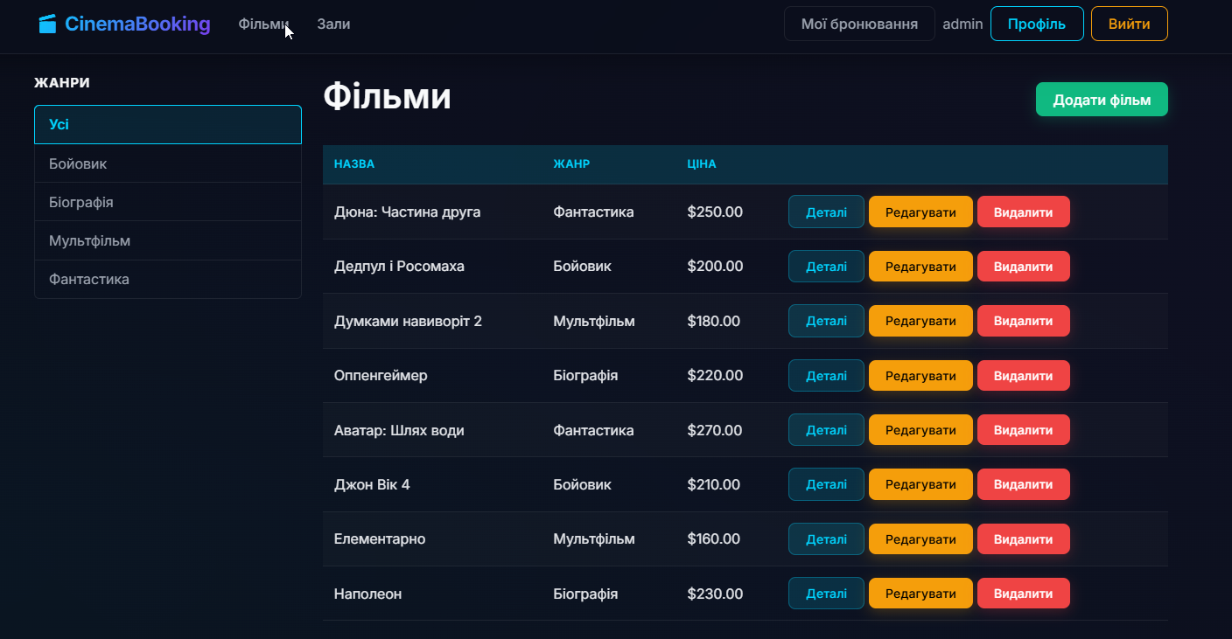
Рис. 2. Роль адміна

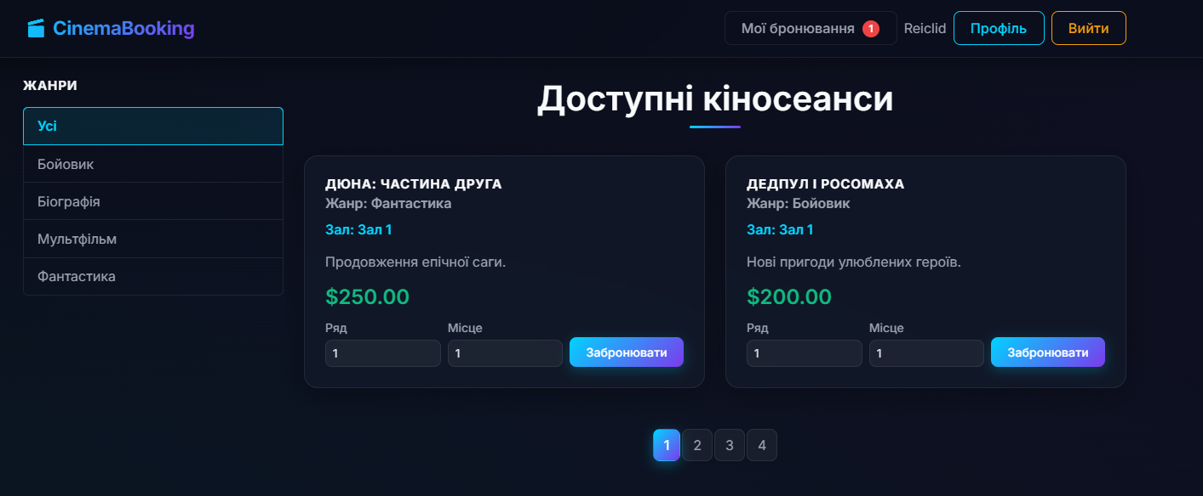
Рис. 4. Роль користувача

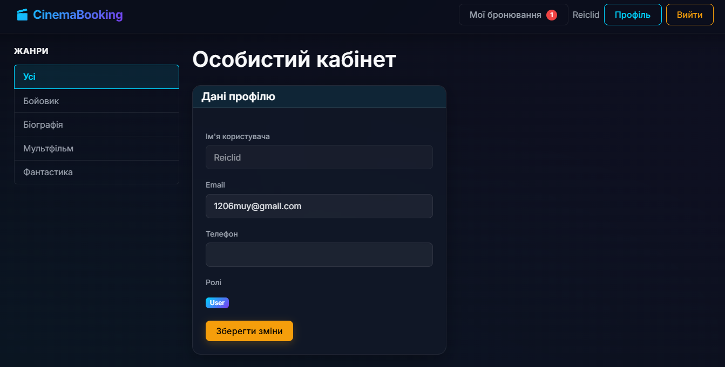
Рис. 5. Профіль користувача

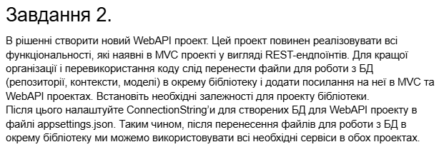
Лістинг коду(CRUD операції кінозалу):
using Microsoft.AspNetCore.Authorization;
using Microsoft.AspNetCore.Mvc;
using CinemaBooking.Data;
using CinemaBooking.Data.Models;

namespace CinemaBooking.Api.Controllers
{
[Route("api/[controller]")]
[ApiController]
[Authorize]
public class CinemaHallsController : ControllerBase
{
private ICinemaRepository repository;

public CinemaHallsController(ICinemaRepository repo)
{
repository = repo;
}

[HttpGet]
[AllowAnonymous]
public IActionResult GetAll()
{
return Ok(repository.CinemaHalls.ToList());
}

[HttpGet("{id}")]
[AllowAnonymous]
public IActionResult Get(long id)
{
var hall = repository.CinemaHalls.FirstOrDefault(h => h.CinemaHallID == id);
if (hall == null) return NotFound();
hall.Movies = repository.Movies.Where(m => m.CinemaHallID == id).ToList();
return Ok(hall);
}

[HttpPost]
[Authorize(Roles = "Admin")]
public IActionResult Create([FromBody] CinemaHall hall)
{
if (!ModelState.IsValid) return BadRequest(ModelState);
repository.CreateCinemaHall(hall);
return CreatedAtAction(nameof(Get), new { id = hall.CinemaHallID }, hall);
}

[HttpPut("{id}")]
[Authorize(Roles = "Admin")]
public IActionResult Update(long id, [FromBody] CinemaHall hall)
{
var existing = repository.CinemaHalls.FirstOrDefault(h => h.CinemaHallID == id);
if (existing == null) return NotFound();
existing.Name = hall.Name;
existing.Capacity = hall.Capacity;
existing.Location = hall.Location;
repository.SaveCinemaHall(existing);
return Ok(existing);
}

[HttpDelete("{id}")]
[Authorize(Roles = "Admin")]
public IActionResult Delete(long id)
{
var hall = repository.CinemaHalls.FirstOrDefault(h => h.CinemaHallID == id);
if (hall == null) return NotFound();
repository.DeleteCinemaHall(hall);
return NoContent();
}
}
}

Лістинг коду(CRUD операції фільмів):
using Microsoft.AspNetCore.Authorization;
using Microsoft.AspNetCore.Mvc;
using CinemaBooking.Data;
using CinemaBooking.Data.Models;

namespace CinemaBooking.Api.Controllers
{
[Route("api/[controller]")]
[ApiController]
[Authorize]
public class MoviesController : ControllerBase
{
private ICinemaRepository repository;

public MoviesController(ICinemaRepository repo)
{
repository = repo;
}

[HttpGet]
[AllowAnonymous]
public IActionResult GetAll()
{
return Ok(repository.Movies.ToList());
}

[HttpGet("{id}")]
[AllowAnonymous]
public IActionResult Get(long id)
{
var movie = repository.Movies.FirstOrDefault(m => m.MovieID == id);
if (movie == null) return NotFound();
return Ok(movie);
}

[HttpPost]
[Authorize(Roles = "Admin")]
public IActionResult Create([FromBody] Movie movie)
{
if (!ModelState.IsValid) return BadRequest(ModelState);
repository.CreateMovie(movie);
return CreatedAtAction(nameof(Get), new { id = movie.MovieID }, movie);
}

[HttpPut("{id}")]
[Authorize(Roles = "Admin")]

public IActionResult Update(long id, [FromBody] Movie movie)
{
var existing = repository.Movies.FirstOrDefault(m => m.MovieID == id);
if (existing == null) return NotFound();
existing.Title = movie.Title;
existing.Description = movie.Description;
existing.Genre = movie.Genre;
existing.TicketPrice = movie.TicketPrice;
existing.CinemaHallID = movie.CinemaHallID;
repository.SaveMovie(existing);
return Ok(existing);
}

[HttpDelete("{id}")]
[Authorize(Roles = "Admin")]
public IActionResult Delete(long id)
{
var movie = repository.Movies.FirstOrDefault(m => m.MovieID == id);
if (movie == null) return NotFound();
repository.DeleteMovie(movie);
return NoContent();
}
}
}

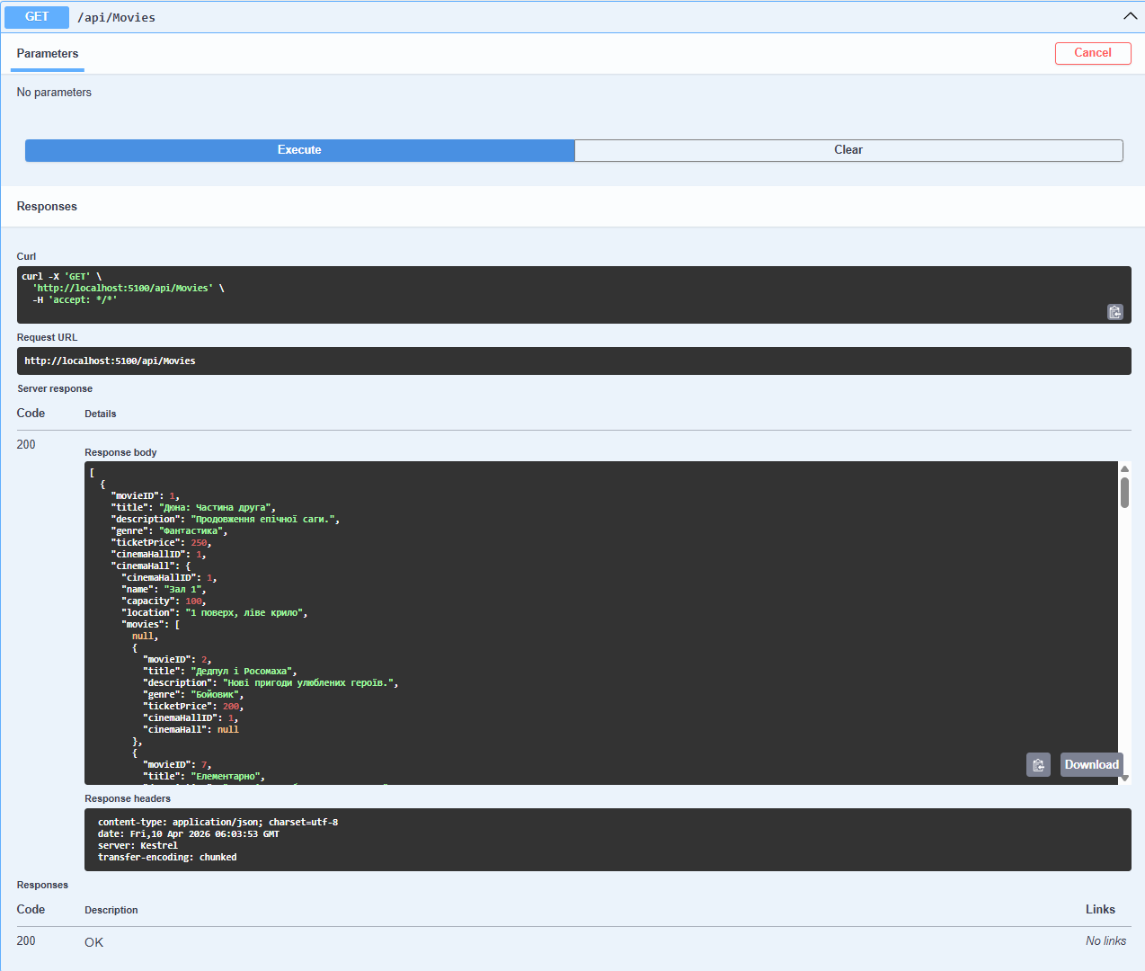
Рис. 6. Операція отримання фільмів

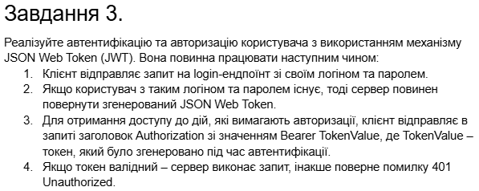
Лістинг коду(AccountController):
using Microsoft.AspNetCore.Identity;
using Microsoft.AspNetCore.Mvc;
using Microsoft.IdentityModel.Tokens;
using System.IdentityModel.Tokens.Jwt;
using System.Security.Claims;
using System.Text;

namespace CinemaBooking.Api.Controllers
{
[Route("api/[controller]")]
[ApiController]
public class AccountController : ControllerBase
{
private UserManager<IdentityUser> userManager;
private RoleManager<IdentityRole> roleManager;
private IConfiguration configuration;

public AccountController(UserManager<IdentityUser> userMgr,
RoleManager<IdentityRole> roleMgr,
IConfiguration config)
{
userManager = userMgr;
roleManager = roleMgr;
configuration = config;
}

[HttpPost("register")]
public async Task<IActionResult> Register([FromBody] RegisterRequest model)
{
var user = new IdentityUser
{
UserName = model.UserName,
Email = model.Email
};

var result = await userManager.CreateAsync(user, model.Password);
if (result.Succeeded)
{
string role = model.Role ?? "User";
if (await roleManager.RoleExistsAsync(role))
{
await userManager.AddToRoleAsync(user, role);
}
return Ok(new { Message = "Користувача зареєстровано успішно" });
}

return BadRequest(result.Errors);
}

[HttpPost("login")]
public async Task<IActionResult> Login([FromBody] LoginRequest model)
{
var user = await userManager.FindByNameAsync(model.UserName);
if (user != null && await userManager.CheckPasswordAsync(user, model.Password))
{
var roles = await userManager.GetRolesAsync(user);

var claims = new List<Claim>
{
new Claim(ClaimTypes.Name, user.UserName!),
new Claim(ClaimTypes.NameIdentifier, user.Id),
new Claim(JwtRegisteredClaimNames.Jti, Guid.NewGuid().ToString())
};

foreach (var role in roles)
{
claims.Add(new Claim(ClaimTypes.Role, role));
}

var key = new SymmetricSecurityKey(
Encoding.UTF8.GetBytes(configuration["Jwt:Key"]!));
var creds = new SigningCredentials(key, SecurityAlgorithms.HmacSha256);

var token = new JwtSecurityToken(
issuer: configuration["Jwt:Issuer"],
audience: configuration["Jwt:Audience"],
claims: claims,
expires: DateTime.Now.AddHours(3),
signingCredentials: creds
);

return Ok(new
{
Token = new JwtSecurityTokenHandler().WriteToken(token),
Expiration = token.ValidTo
});
}

return Unauthorized(new { Message = "Невірне ім'я або пароль" });
}
}

public class RegisterRequest
{
public string UserName { get; set; } = string.Empty;
public string Email { get; set; } = string.Empty;
public string Password { get; set; } = string.Empty;
public string? Role { get; set; }
}

public class LoginRequest
{
public string UserName { get; set; } = string.Empty;
public string Password { get; set; } = string.Empty;
}
}

Лістинг коду(Program):
using Microsoft.EntityFrameworkCore;
using Microsoft.AspNetCore.Identity;
using Microsoft.AspNetCore.Authentication.JwtBearer;
using Microsoft.IdentityModel.Tokens;
using System.Text;
using CinemaBooking.Data;

var builder = WebApplication.CreateBuilder(args);

builder.Services.AddControllers()
.AddJsonOptions(opts => {
opts.JsonSerializerOptions.ReferenceHandler =
System.Text.Json.Serialization.ReferenceHandler.IgnoreCycles;
});

builder.Services.AddEndpointsApiExplorer();
builder.Services.AddSwaggerGen();

builder.Services.AddDbContext<CinemaDbContext>(opts => {
opts.UseSqlite(builder.Configuration["ConnectionStrings:CinemaConnection"]);
});

builder.Services.AddDbContext<AppIdentityDbContext>(opts => {
opts.UseSqlite(builder.Configuration["ConnectionStrings:IdentityConnection"]);
});

builder.Services.AddIdentity<IdentityUser, IdentityRole>(opts => {
opts.Password.RequiredLength = 8;
opts.Password.RequireDigit = true;
opts.Password.RequireLowercase = true;
opts.Password.RequireUppercase = true;
opts.Password.RequireNonAlphanumeric = false;
opts.User.RequireUniqueEmail = true;
}).AddEntityFrameworkStores<AppIdentityDbContext>();

builder.Services.AddAuthentication(opts => {
opts.DefaultAuthenticateScheme = JwtBearerDefaults.AuthenticationScheme;
opts.DefaultChallengeScheme = JwtBearerDefaults.AuthenticationScheme;
})
.AddJwtBearer(opts => {
opts.TokenValidationParameters = new TokenValidationParameters
{
ValidateIssuer = true,
ValidateAudience = true,
ValidateLifetime = true,
ValidateIssuerSigningKey = true,
ValidIssuer = builder.Configuration["Jwt:Issuer"],
ValidAudience = builder.Configuration["Jwt:Audience"],
IssuerSigningKey = new SymmetricSecurityKey(
Encoding.UTF8.GetBytes(builder.Configuration["Jwt:Key"]!))
};
});

builder.Services.AddScoped<ICinemaRepository, EFCinemaRepository>();

var app = builder.Build();

if (app.Environment.IsDevelopment())
{
app.UseSwagger();
app.UseSwaggerUI();
}

app.UseAuthentication();
app.UseAuthorization();

app.MapControllers();

SeedData.EnsurePopulated(app);
IdentitySeedData.EnsurePopulated(app).Wait();

app.Run();

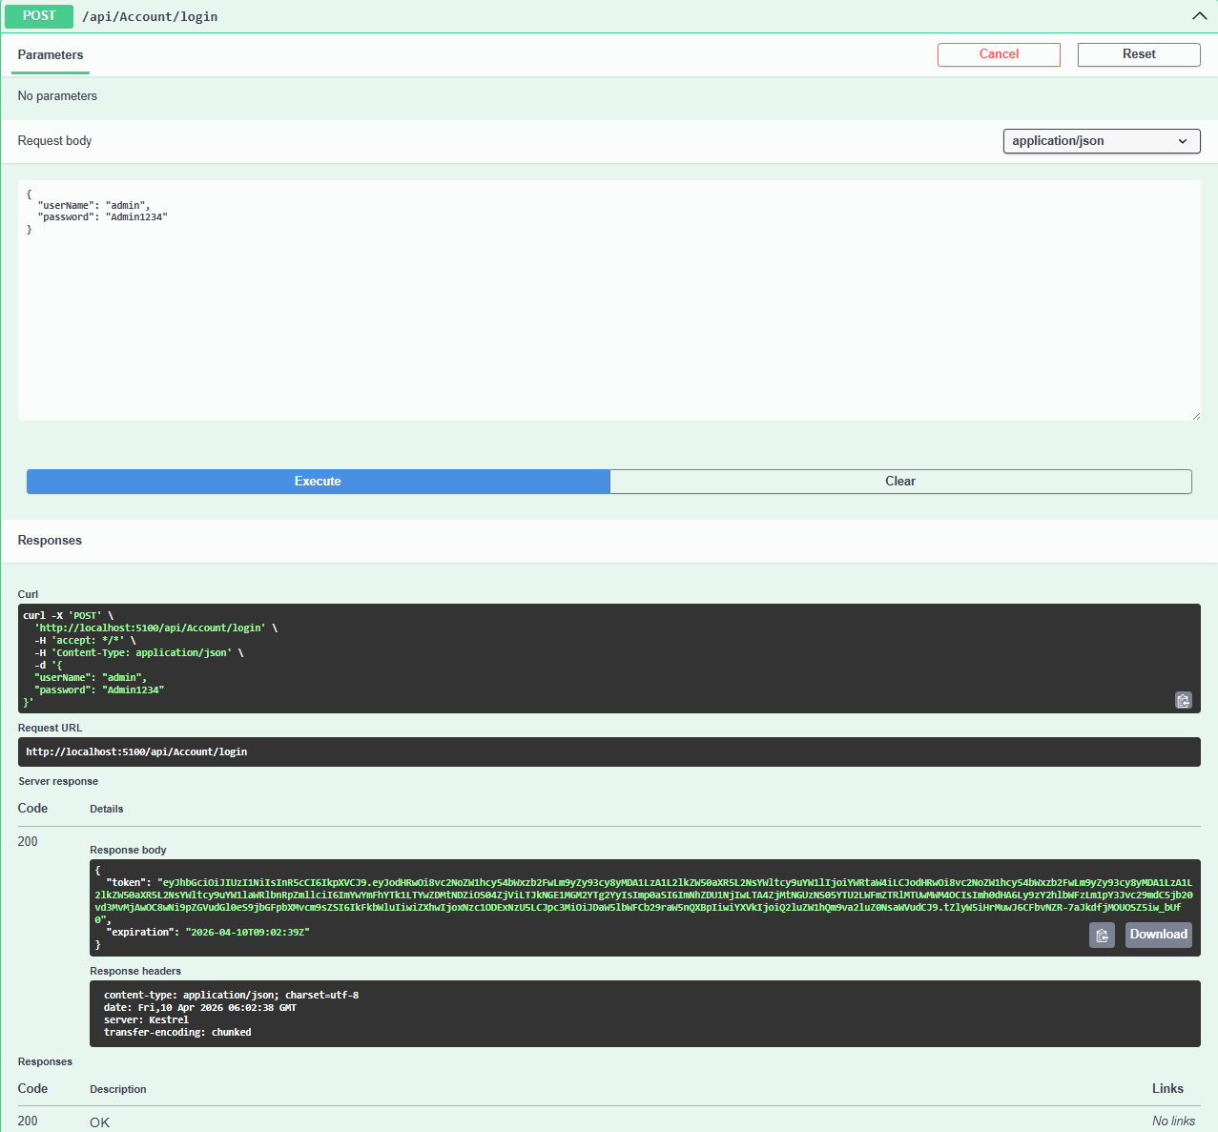
Рис. 7. Операція логіну

Висновок: в ході виконання роботи набув навичок роботи з механізмами аутентифікації та авторизації користувачів в ASP.NET, набув навичок роботи з Web API.

